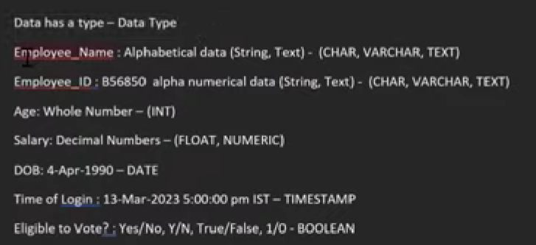

**TYPE OF DATA STRUCTURE**

Semi structured data is combination of both structure and un structure data

